# Chapter 5: Scenario Based Modeling

This chapter describes the scenario based model for the

## 5.1 Introduction

## 5.2 Definition of Use case

## 5.3 Use Case Diagrams

## 5.4 Activity and Swim lane diagram

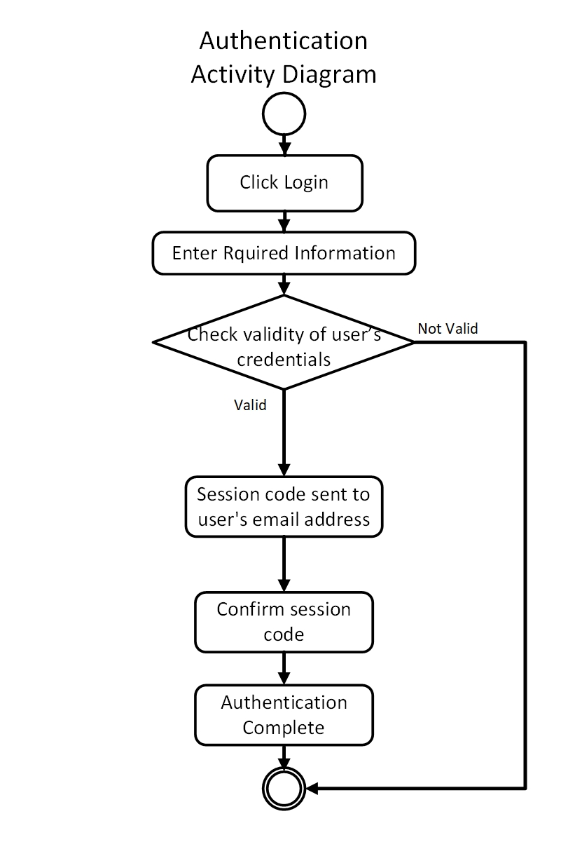**Activity diagram** shows the technical view of the system for every use case  
from which we can understand how the system actually works and how the actors interact with the system. Here is the activity diagram for our authentication system.

Figure: Activity for Authentication

**Swim lane** diagram of a specific activity diagram shows the responsibilities of each actor dividing them into lanes. From this diagram we can improve our understanding about how the system works and which actors play what role.

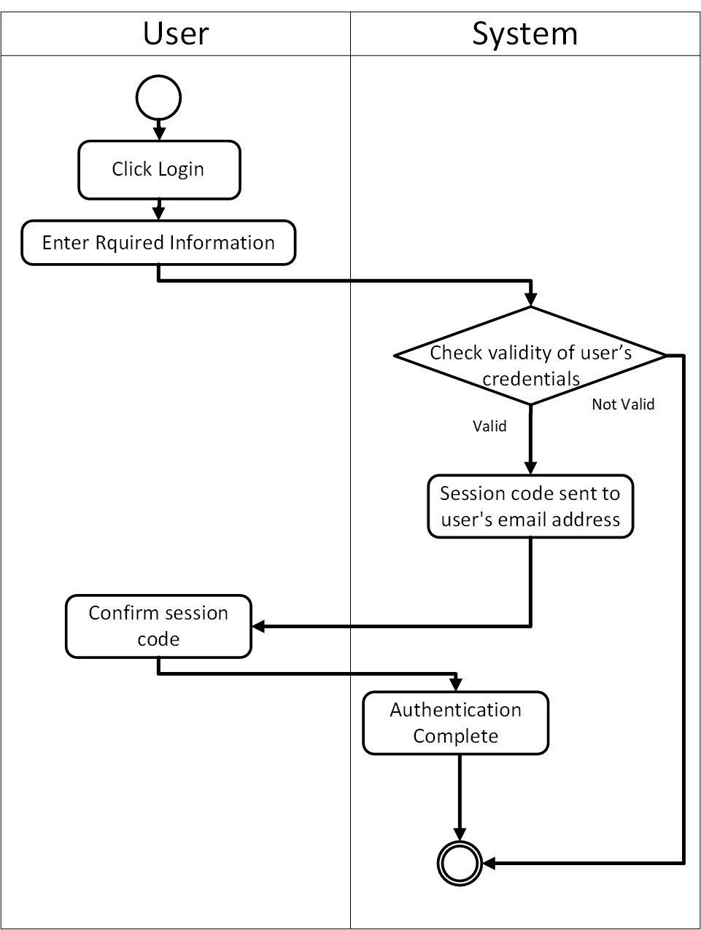Following is the swim lane for authentication system.

Figure: Swim lane for Authentication

Following is the activity diagram for user graduate students.

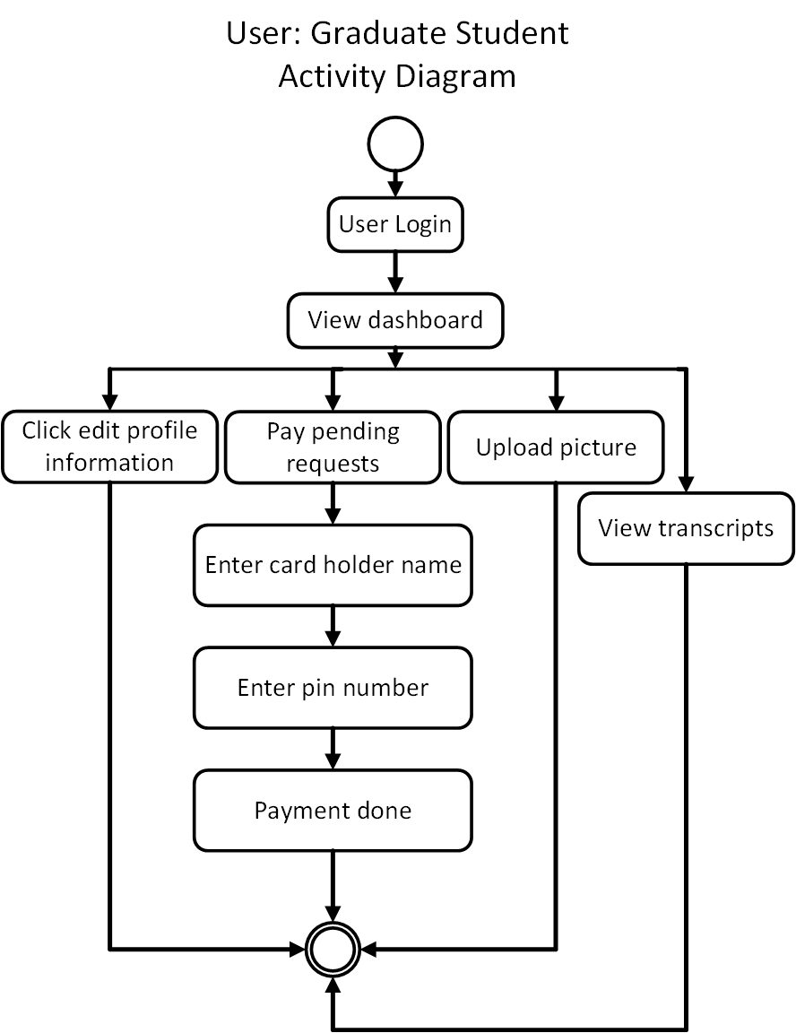

Figure: Activity of Graduate Students

Following is the swim lane diagram for user Graduate students.

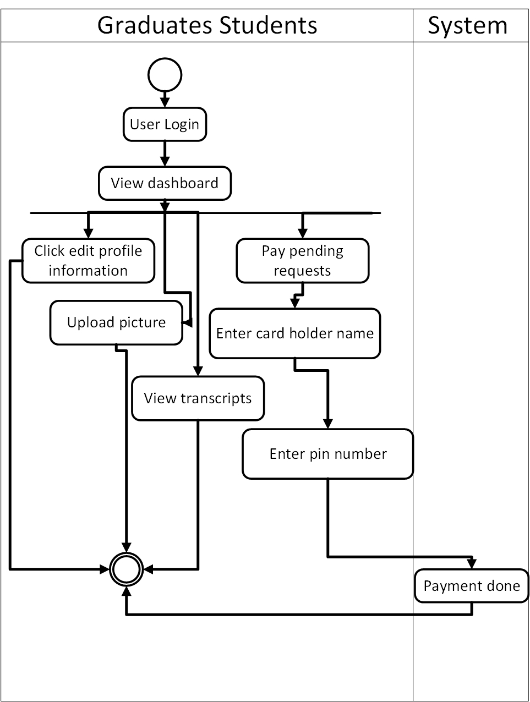

Figure: Swim lane for Graduate Students

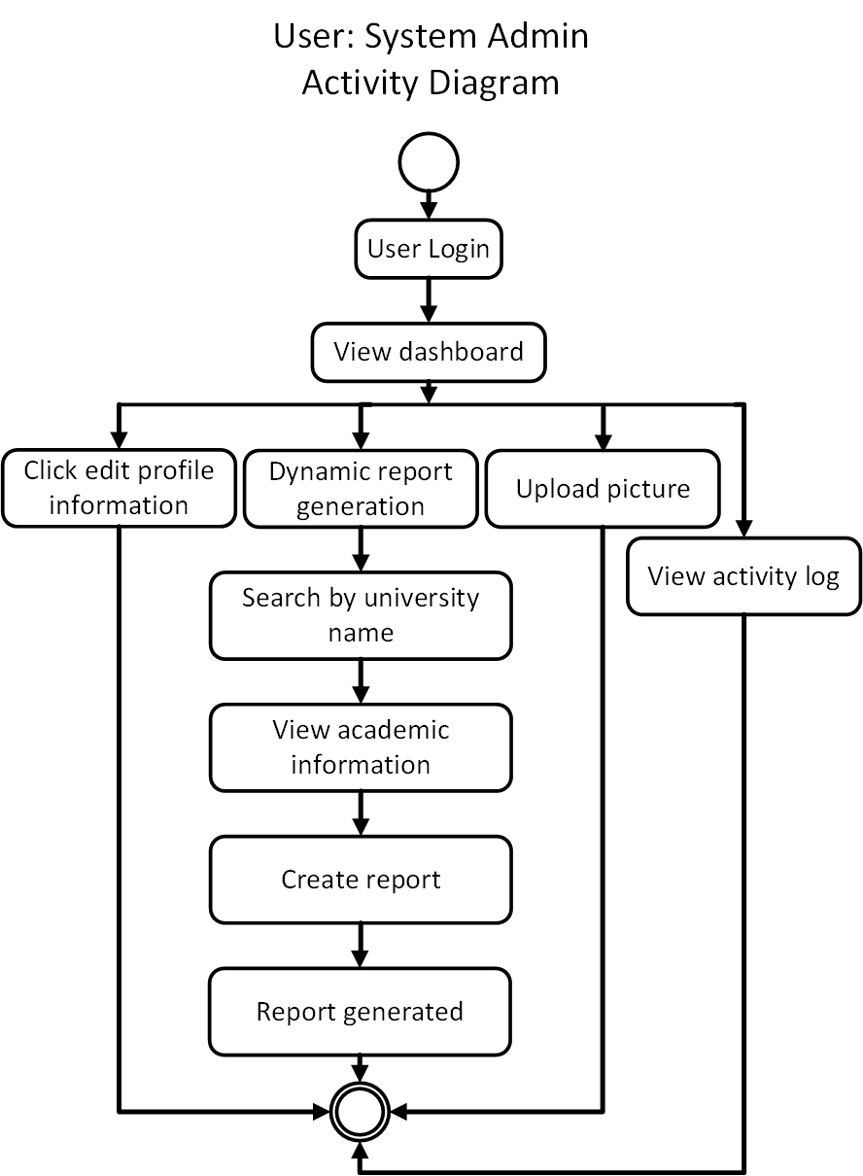Following is the activity diagram for System Admin.

Figure: Activity for System Admin

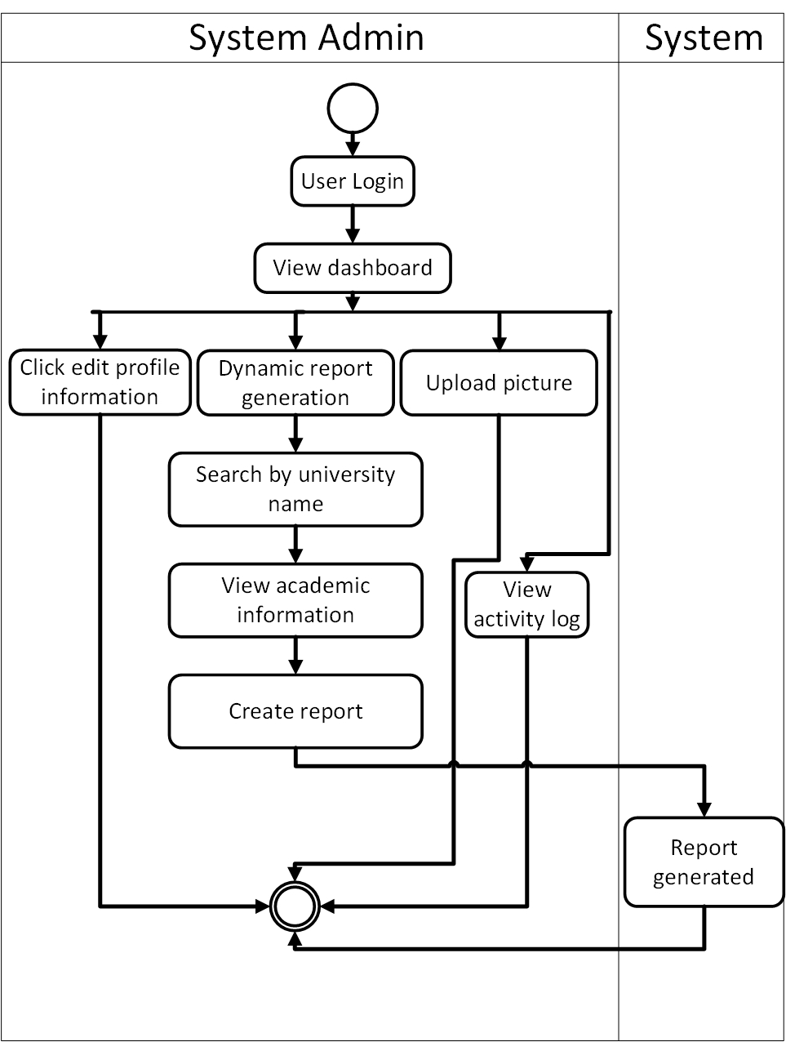Following is the swim lane diagram for System Admin.

Figure: Swim lane for System Admin

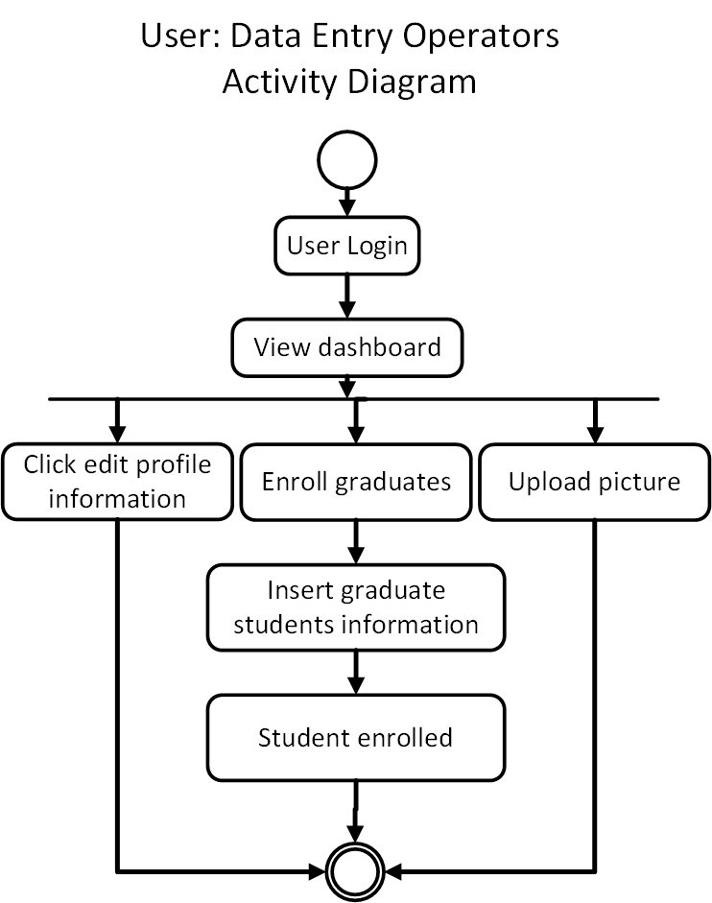Following is the activity diagram for Data Entry Operators.

Figure: Activity for Data Entry Operators

Following is the swim lane for Data Entry Operators.

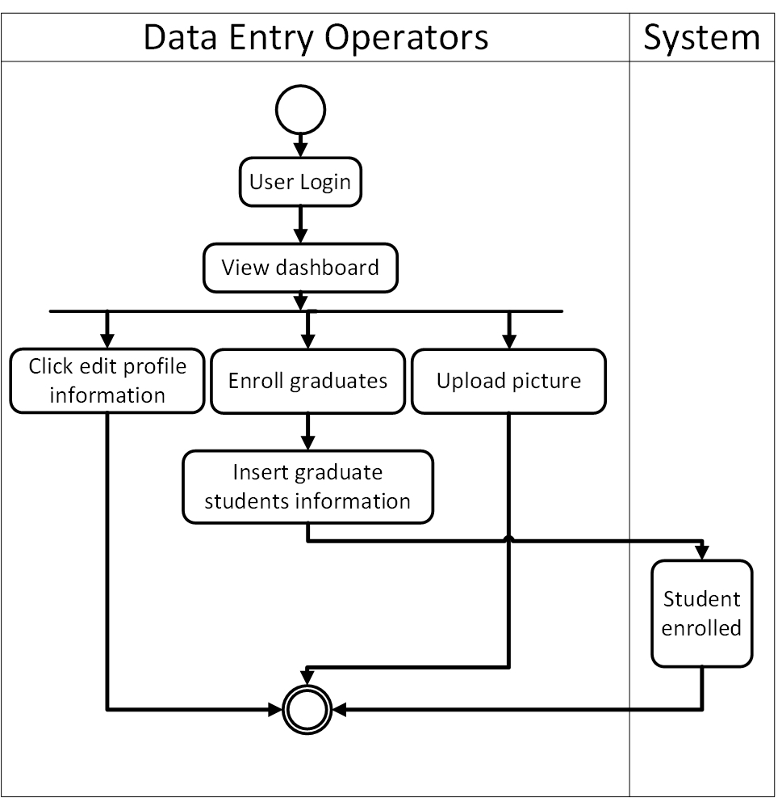

Figure: Swim lane for Data Entry Operators

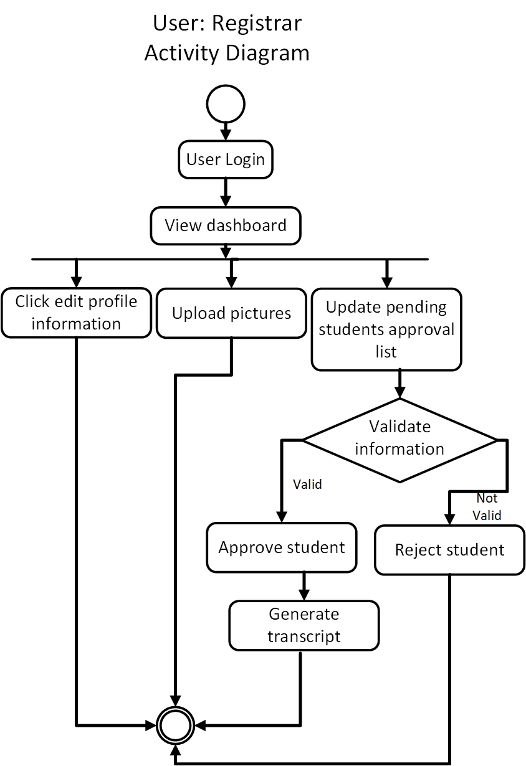Following is the activity diagram for Registrar.

Figure: Activity diagram for Registrar

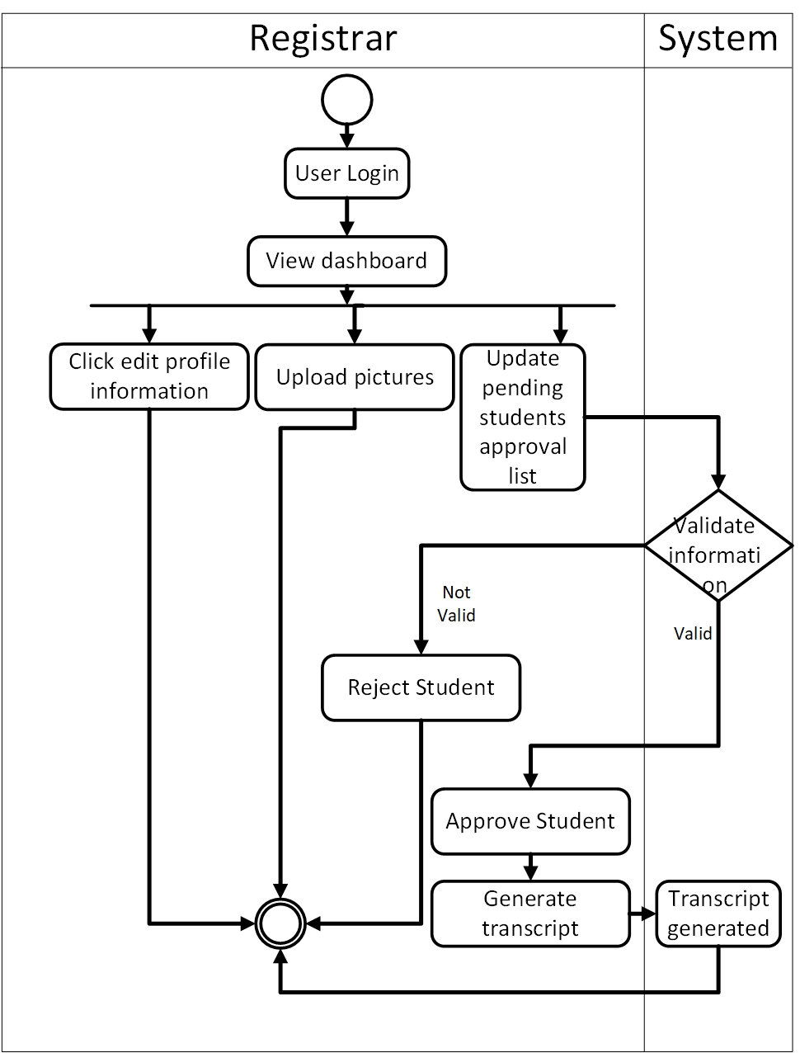Following is the swim lane for registrar..

Figure: Swim lane for Registrar

Following is the activity diagram for foreign universities.

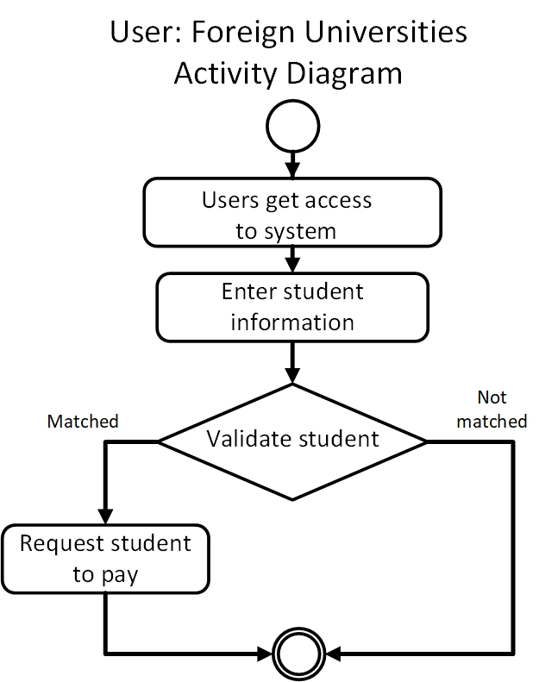

## 

Figure: Activity for Foreign Universities

Following is the swim lane diagram for Foreign Universities.

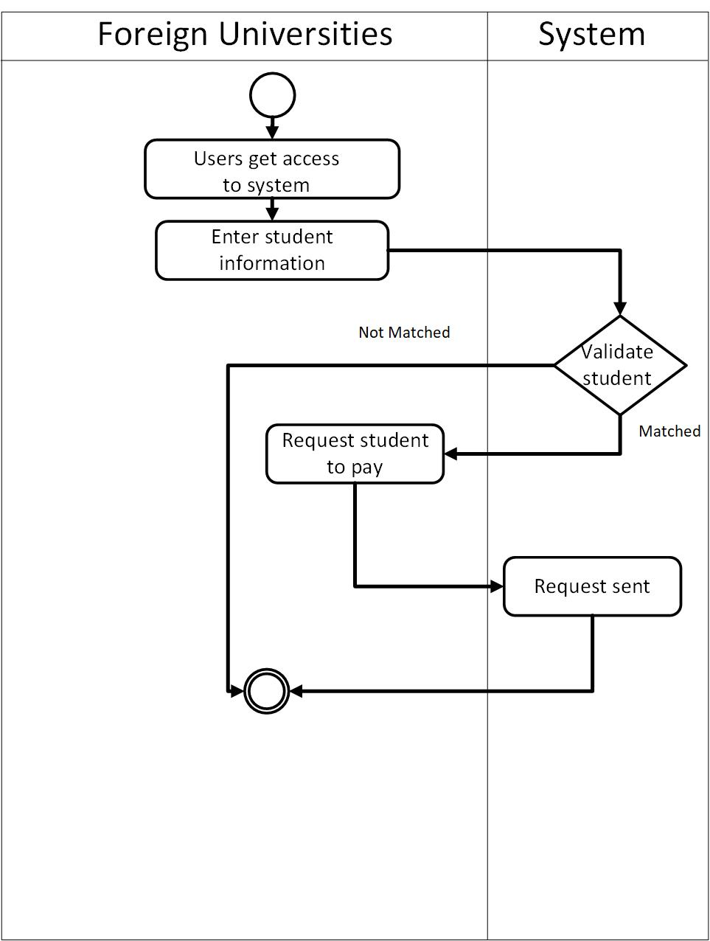

Figure: Swim lane for Foreign Universities